  ICAPE  International |  |  |  | Customer Name: Valentinea
 |  |  |  | Customer P/N: SI945D
 |  | Note I: Please declare your technical questions with simple, clear, logic and professional sentence in English.  Note II: Please kindly check the following technical questions item by item and reply within a working day |  | Supplier P/N: 042113084A0
Question |  |  | Suggestion |  | Client Reply
1 | See this picture below, the etch texts in circuit layer is very closed to the outline(board edge)，it will take a risk of track damaged and exposure during processing.  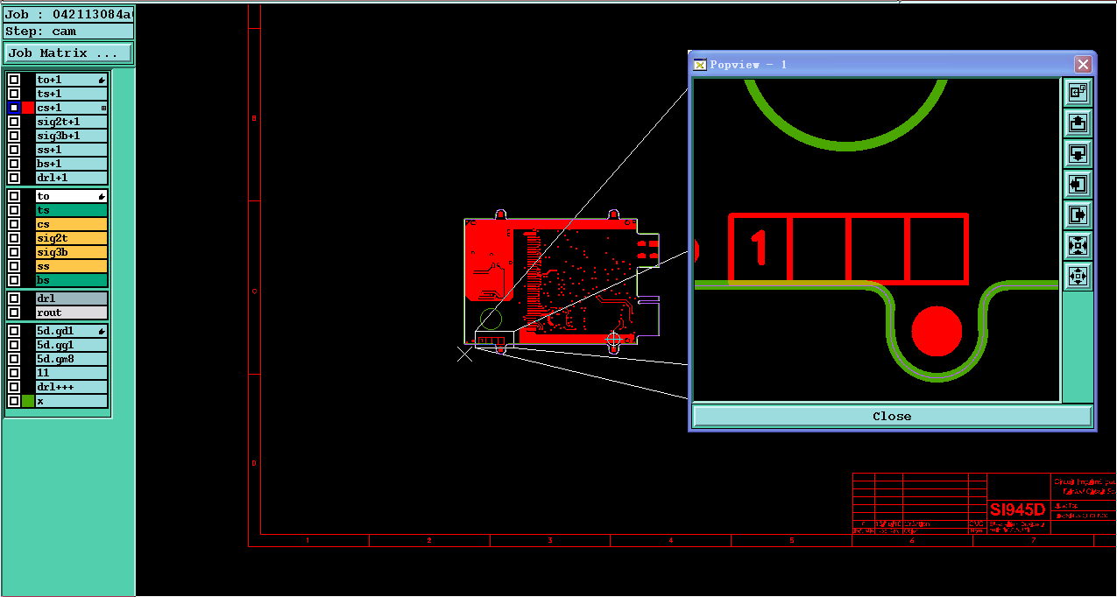 |  | In order to avoid this risk, we'll move up the etch texts 10mil of four layer away from the center of board outline.  Please confirm.  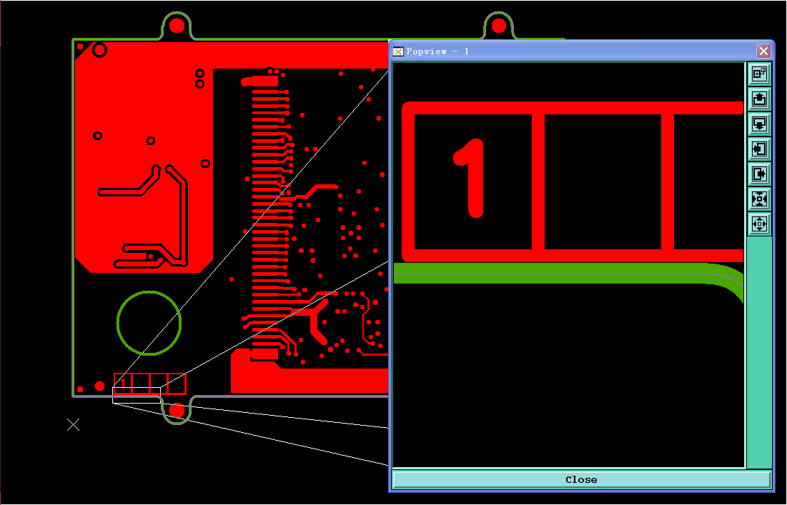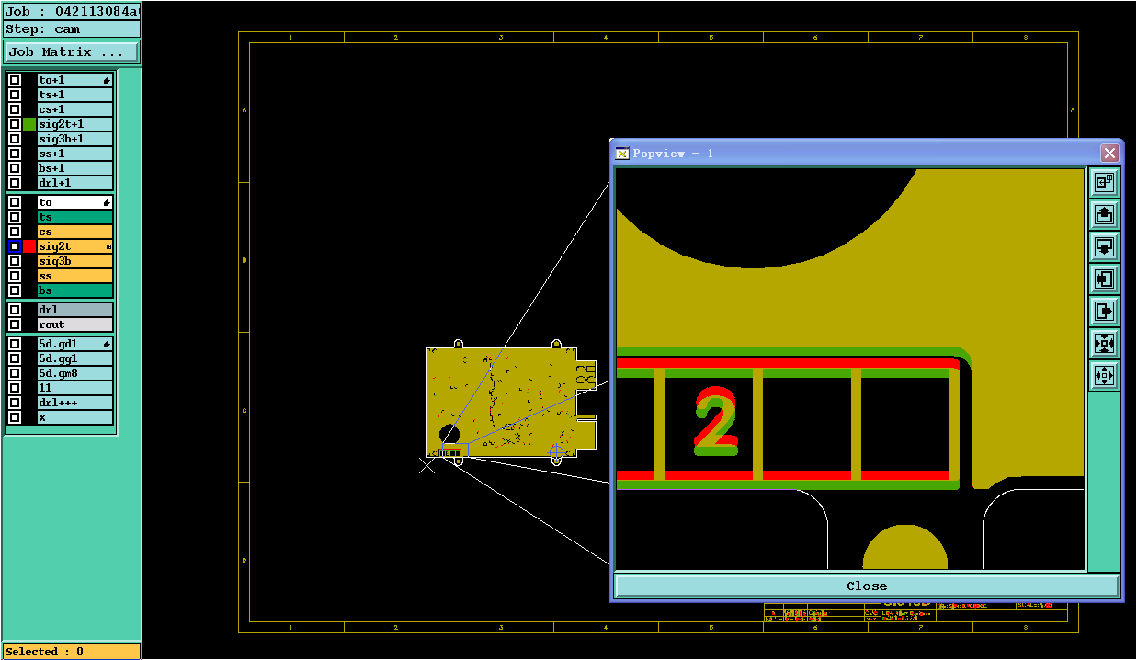 |  | OK
2 | See this picture below, the plated holes are larger than copper PADs and without any net connection on bottom side only, but they have normal copper pads on top side.  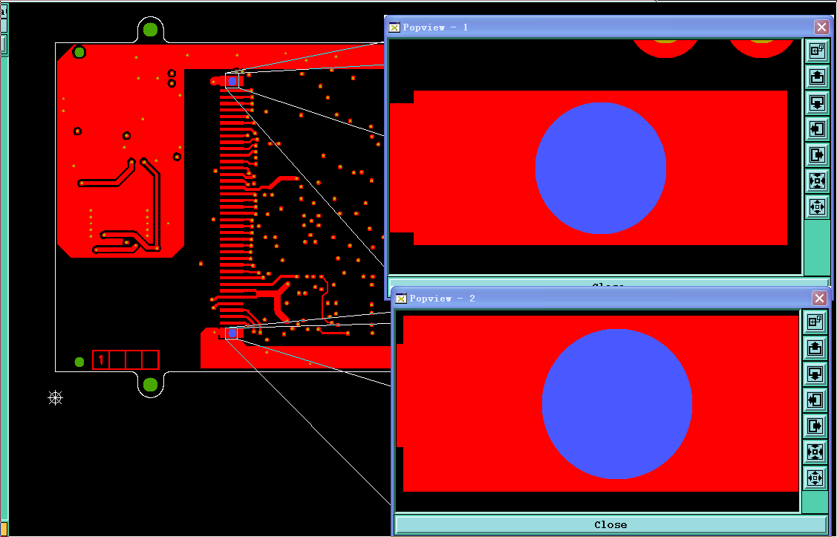--→top side  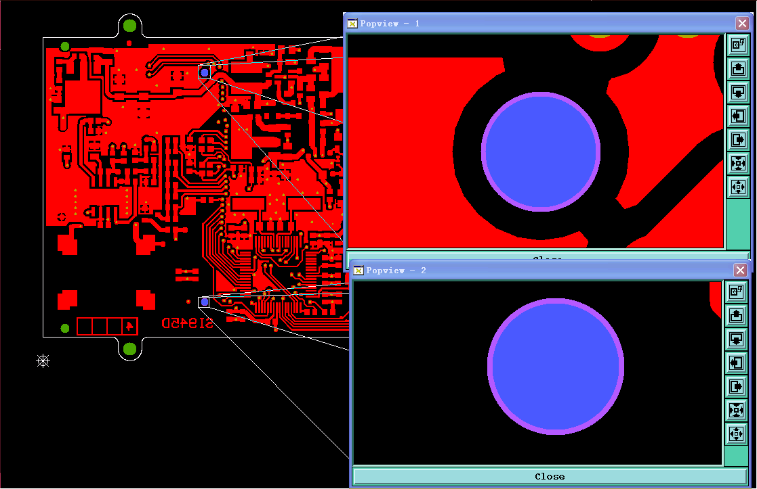→bottom side |  | We will do it for plated holes without pad ring on bottom side.  Please confirm. |  | The top plated hole should be connected to the ground plane on the bottom side like on the previous version of the board :  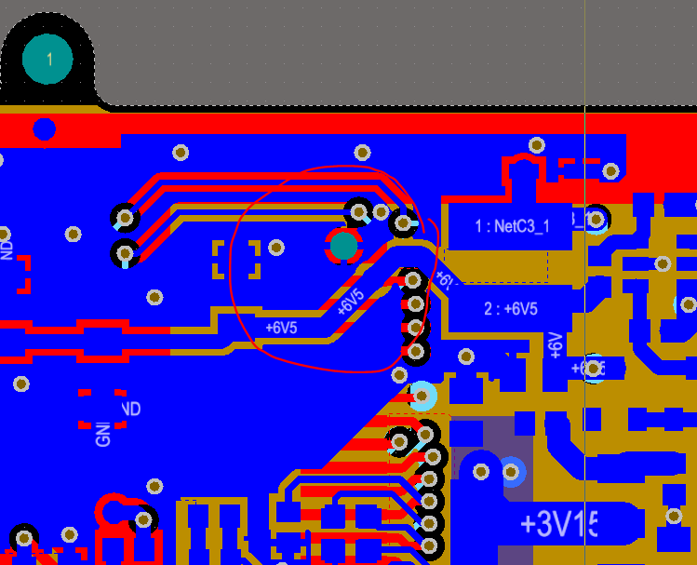  What do you suggest ?
3 | See this picture below, these two copper pads are touch to the outline, which will cause exposed copper on the finish board.  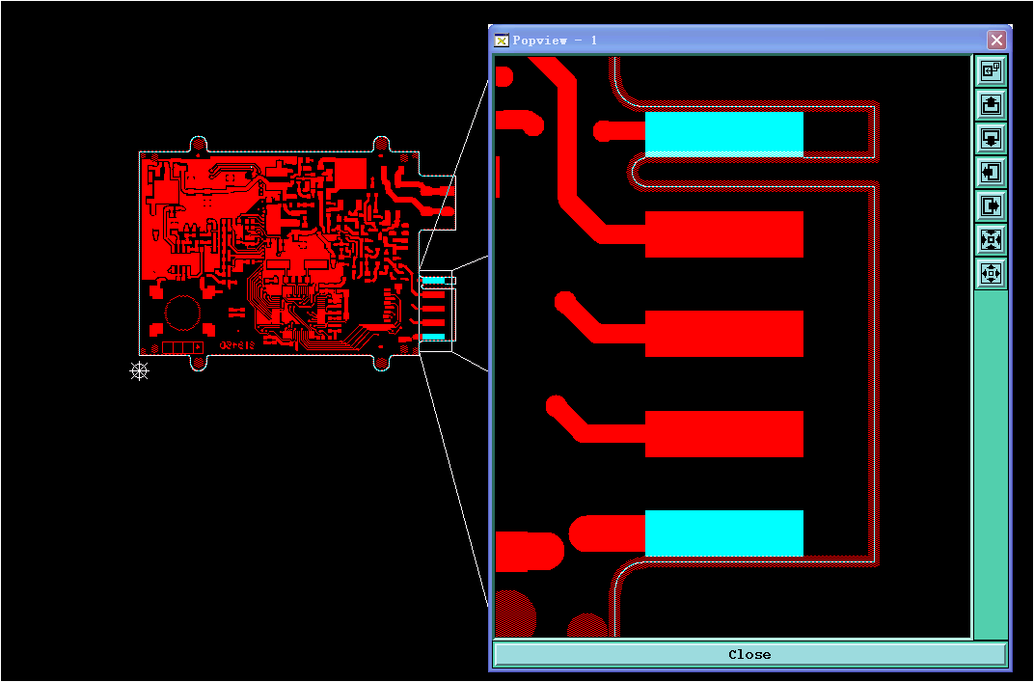 |  | In order to avoid to copper exposure at the edge of board, suggest properly trim the IC pads are allowed.  Please confirm. |  | Copper exposure on these pads is not a problem. It's been made like this on purpose.  Don't change anything.
4 | See this picture below, the SMT pad is so close to each other, which is less than 7.2mil, it is very difficult to keep the solder mask bridge between the SMT.  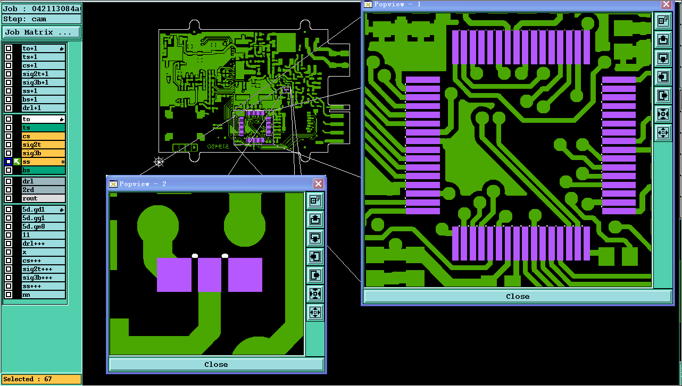 |  | Suggest 1: no solder mask bridge between the SMT is ok, see below:  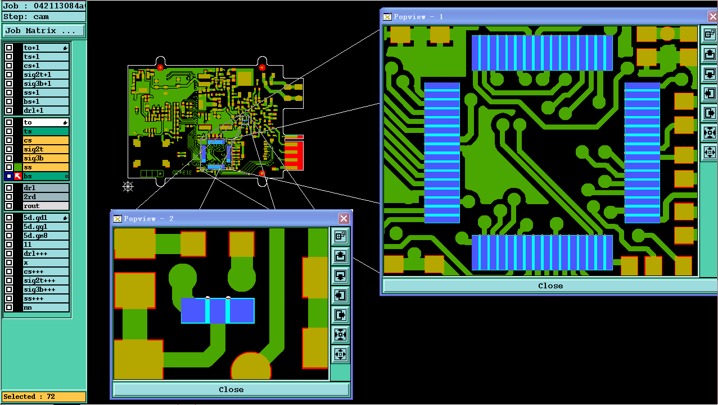  Suggest 2: shave SMD single side 0.65mil and make out solder mask bridge.  Please choice 1 or 2. |  | Use suggest 1.  I don' know where you saw solder mask bridges on the microcontroller because on the CAD and gerbers it's like this :  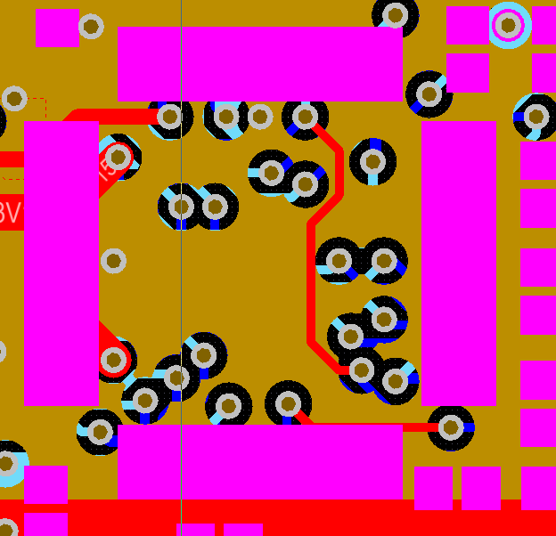
5 | Please confirm the marking requirements. |  | Suggest add our all markings on silk screen top side, and the D/C with WWYY in format.  Please confirm.  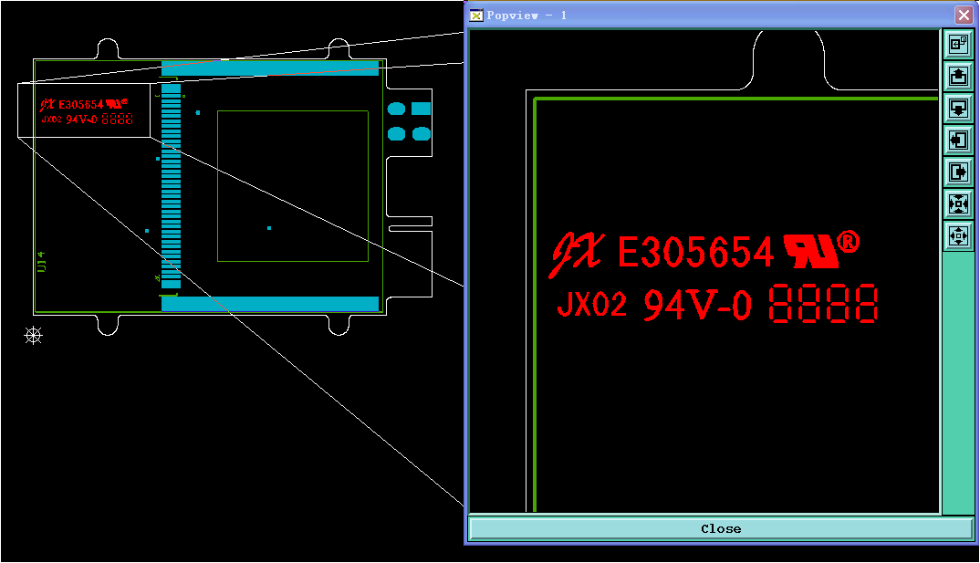 |  | OK
6 | Some PCB manufacture specification is not defined, we suggest do as below suggestion:  - Base material: FR4, TG130°;  - Board thickness:1.6mm+/-10%;  - Finish copper thickness:35um on outer layers, and min. 24.9um for inner layer per IPC 6012 Class 2;  - Surface finish: HASL-Lead free;  - Solder mask color: Green  - Silkscreen color: White. |  | Please help to confirm from 1 to 6. |  | OK
7 | We received your panel design requirement, and we make a panel drawing attached for your approval. |  | Please check attached our panel drawing and confirm if it’s ok? |  | See attached files.
8 | See the picture blow, the amount of holes in drill map is different from it in gerber file.  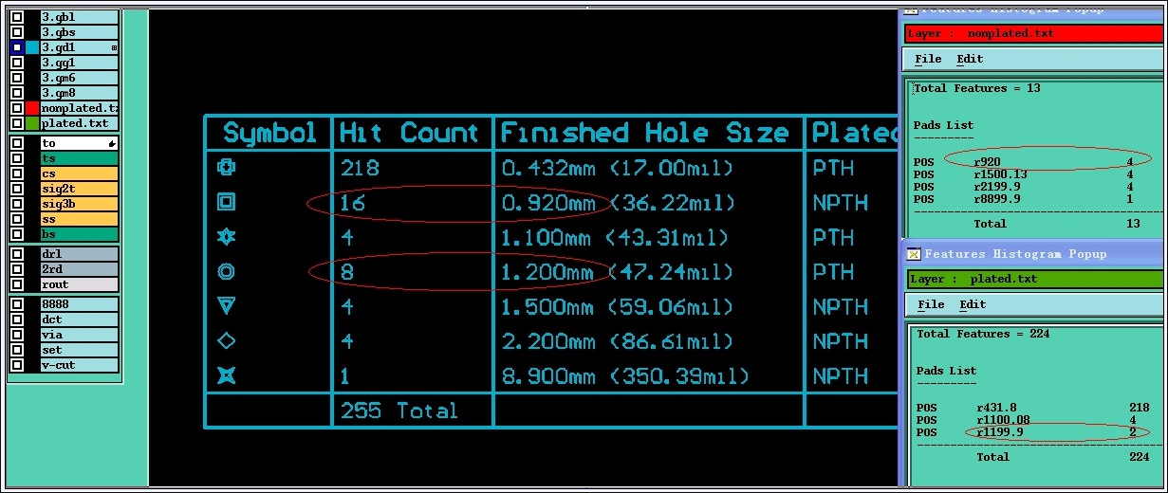 |  | Suggest to ignore the difference and follow gerber to build.  please confirm. |  | Follow gerber build.

Supplier: Checked by: | Henry Date:  2016-12-21 |  |  | Customer:  Approved by: | Date:

